A Mini Project Report
on
ONLINE ART GALLERY

By
<SANJANA REDDY>-<1602-13-733-042>
<GANNU VINEEL>-<1602-13-733-058>


Department of Computer Science & Engineering
Vasavi College of Engineering
(Autonomous)
Ibrahimbagh, Hyderabad-31
2015

ACKNOWLEDGEMENT

It is a genuine pleasure to express my deep sense of thanks and gratitude to my coordinators. Their dedication and keen interest above all their over whelming attitude to help their students had been solely and mainly responsible for completing my work. Their timely advice, meticulous scrutiny, scholarly advice and scientific approach have helped me to a very great extent to accomplish this task.

TABLE OF CONTENTS:

List of Figures iv
List of Tables v
Abstract vi
1. Introduction 1
1.1 Purpose: 1
1.2 Definitions, Acronyms and Abbreviations 1
2. Software Requirement Specification 2
2.1 Software Interface 2
2.2 Hardware Interface 2
3. System Design 3
4. Code 4
4.1 Code to create Login Id 4
4.2 Code for dividing a page into sections 4
5. Screenshots 6
6. Testing 8
7. Conclusion 9
8. References 10

List of Figures:
Use Case Diagram 3

List of Tables:
User Diagram 3

Abstract:
Online Art Gallery is an online application, which is used to display and sell art works of artist irrespective of their nationality, gender and other narrow consideration. Artist can register online for being a member in the art gallery and each artist can upload the digital copy of their art work under the respective categories. They can host their art work. Customer can also register online and they can browse art works that are arranged in different categories identically.

1.0 Introduction:
Online shopping has become very popular to purchase all things without leaving the home, and it is a convenient way to buy things like electronic appliances, furniture, cosmetics, and many more. We can avoid the traffic and crowds.
Online Art Gallery is an online application, which is used to display and sell art works of artist irrespective of their nationality, gender and other narrow consideration. Artist can register online for being a member in the art gallery and each artist can upload the digital copy of their art work under the respective categories. They can host their art work. Customer can also register online and they can browse art works that are arranged in different categories identically.
1.1 Purpose:
The purpose of Online Art Gallery is to display and sell art works of artist irrespective of their nationality, gender and other narrow consideration.
1.2 Definitions, Acronyms and Abbreviations:
HTML (Hyper Text Mark-up Language):
It is used to create static web pages.
CSS (Cascading Style Sheet):
It is a style sheet language used for describing the look and formatting of a document written in a markup language.
MYSQL:
It is a database management system that provides a flexible and efficient data base platform to raise a strong "on demand" business applications.
PHP (Pre processing Hyper Text):
It is a server side scripting language designed for Web development but also used as a general purpose programming language.

2.0 Software requirements Specification:
2.1 Software Interface:

Front End Client: PHP, HTML, CSS, JAVA SCRIPT.

Web Server: Apache Tomcat Version 2.4.9.

Database Server: SQL.

2.2 Hardware Interface:

Client Side: Components to run Data Base server and web server.

Server Side: Minimum of 4GB RAM, 500 GB of Hard Disk.

3.0 System Design:

Website is designed in such a way that when the user signs up then the details of the user is stored in database and when he/she logs in, the system checks whether the input is present in database or not. If it is present then the user can log in else the user cannot.
User Table:
User Id | Username | Password | Gender | Phone number | Mail id

Use Case Diagram:

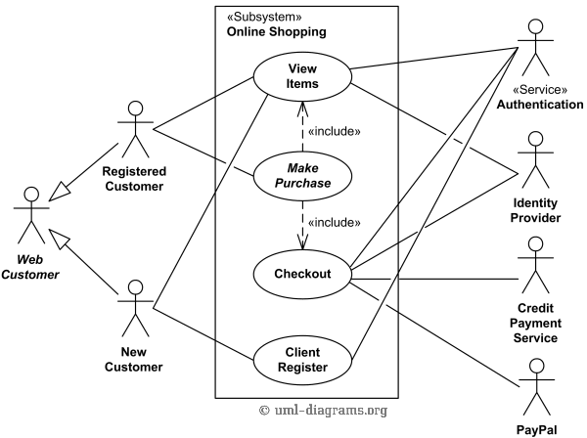

4.0 Code:

4.1. Code to create Login Id:
<label for="username"><font color="orange">username</font></label> <input type="username" id="usename" name="username"><br /><br />
<label for="password"><font color="white">password:</font></label> <input type="password" id="password" name="password"><br /><br />
<button type = "Submit">Login</button>
<button type = "Submit"><a href="SignUp.php">Sign Up</button>

4.2. Code for dividing a page into sections:
<html>
<head>
<title>Drawings</title>
<link rel="stylesheet" type="text/css" href="style.css" />
<style>
background-color:green;
div {
float:left; }
#d1{
background-color:pink;
height:10%;
width:100% }
#d2{
background-color:white;
height:10%;
width:100%; }
#d3{
background-color:indigo;
height:600%;
width:100%; }
h1 {color:blue}
</style>
</head>
</html>

5.0 Screenshots:


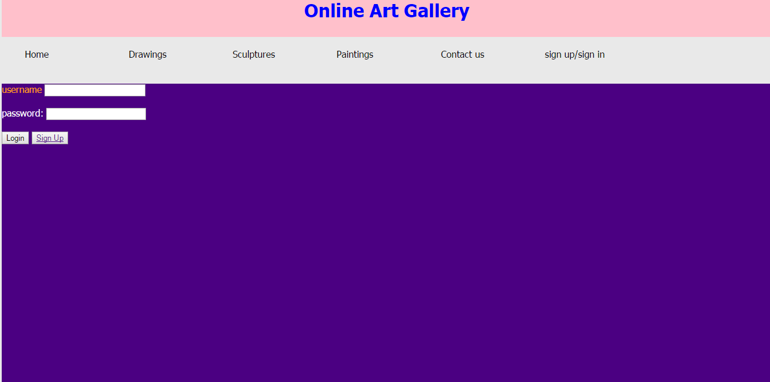

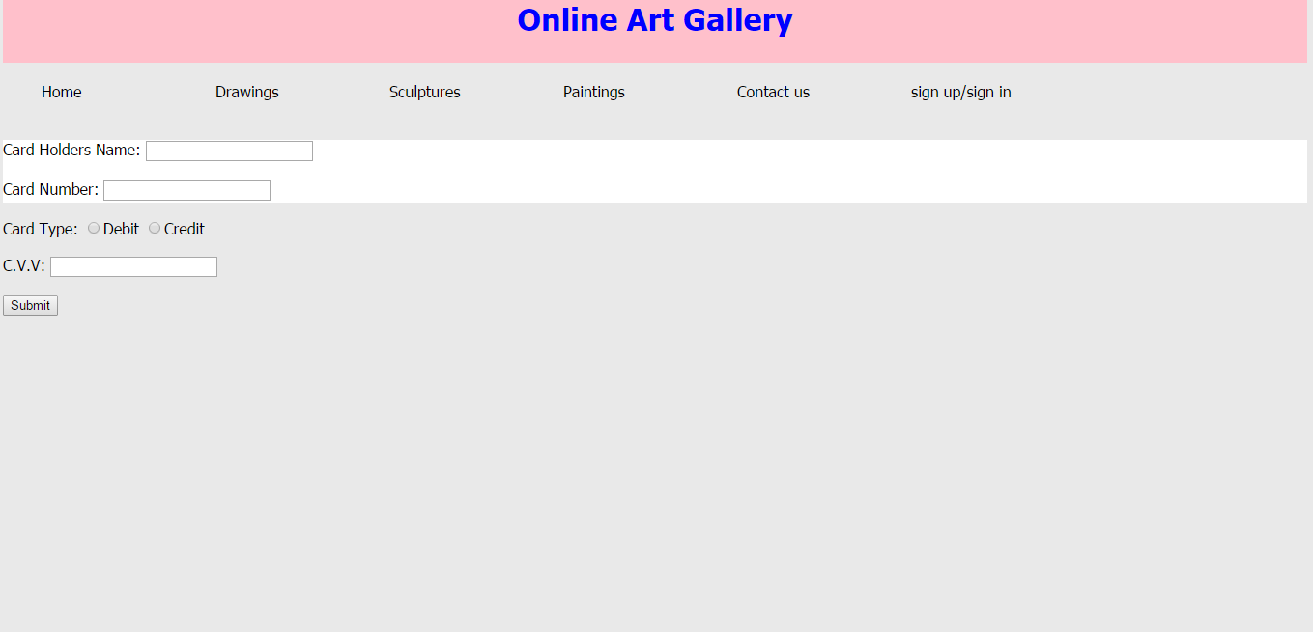

6.0 Testing:
The functionalities that have been tested are:
I. Forms:

i. Field validation.
ii. Error message for wrong input.
iii. Optional and Mandatory fields.

II. Database:
Testing will be done on the database integrity.

III. Performance:
Performance testing can be applied to understand the web site’s scalability, or to benchmark the performance in the environment of third party products such as servers and middleware for potential purchase.
IV. Server Side Interface:
In web testing the server side interface should be tested. This is done by verify that communication is done properly. Compatibility of server with software, hardware, network and database should be tested.

V. Client Side Compatibility:
The client side compatibility is also tested in various platforms, using various browsers etc.

7.0 Conclusion:
The report tells about an Online Art Gallery, the purpose of which is to sell and buy the art works.

8.0 References:
- Database System Concepts 5th edition by Abraham Silberschatz.

- www.w3schools.com [Accessed: 02-september-2015]

